# Stanford Cs231n

# L10- RNN

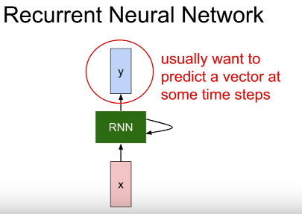

* RNN has some internal hidden state, and that **internal hidden state will be updated every time that the RNN reads a new input**;
* and that hidden state will be fed back to the model the next time it read an input
* recurrence formula inside the green box:

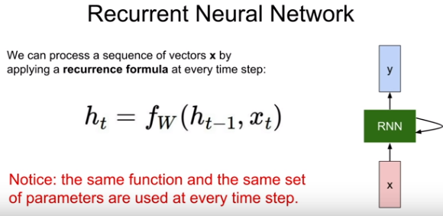

* This function f will depend on weights W, the previous hidden state(ht-1), and current state x as input. And will ouput the next(updated) hidden state
* with the next X(t+1) the new hidden state will be used.
* We might attach some additional FC layers that read this ht at every time step

## Vanilla RNN

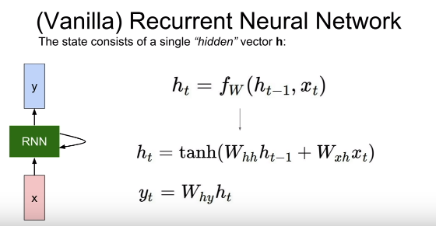

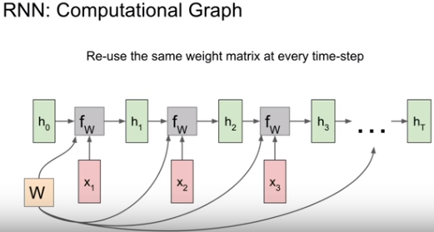

How gradient flows in backpropagation,

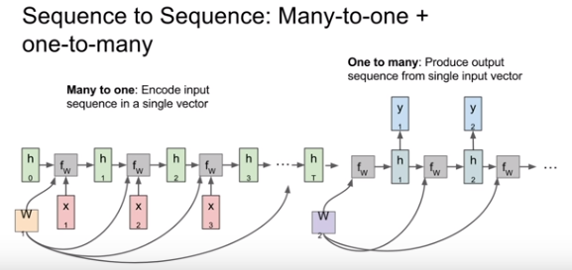

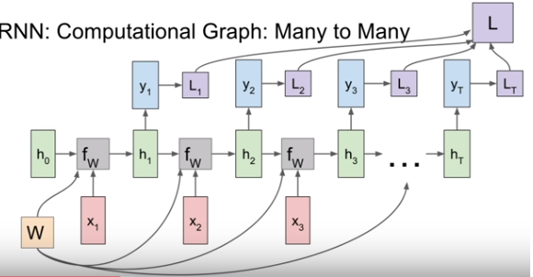

## Sparse/Dense vector:

* **Dense matrices store’s every entry in the matrix.**
* **Sparse** matrices only store’s the **nonzero** entries.

*the elements of a vector have mostly zero values. Such a vector is said to be sparse(seyrek)*

*It is inefficient to use a one-dimensional array to store a sparse vector.*

You sometimes know that your vector will have a lot of ui=0 value. Then you may want, to avoid memory wasting, to store values that are not 0, and then, and consider, other values as zero.

*And for exemple a dense vector (1, 2, 0, 0, 5, 0, 9, 0, 0) will be represented as {(0,1,4,6), (1, 2, 5, 9)}*

*Yellow ones for positions*

## Example

**Language modelling**

1 character level

2 word level

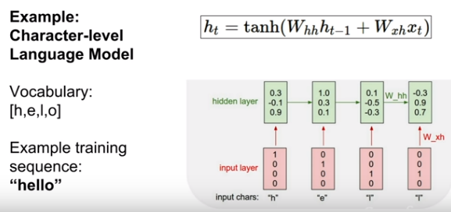

During forward pass,

* At first time step: it will receive the input letter h; will go into 1st RNN cell, and then will produce the output yt(which letter is most likely , in this example model predict letter O ) we’ll use to softmax loss to quantify our unhappiness with these predictions
* In the second step, it has high loss because l has the lowest prob.
* After training with different sequences, the model will learn to predict true.

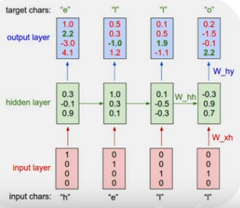

Test time

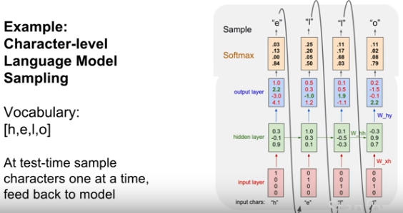

* At test time sample **characters one at a time** feed back to model; taking 1st output to second input and so on.
* we’ll use a softmax function convert those scores into a probabilty distribution
* and then we’ll **sample** from that prob distr. to actually synthesize the second letter in the seq
* **question**: why sampling rather than taking the largest scored char?
  + The prob distr we had(1st prob is 0.83 for char O which is wrong prediction) ,it was impossible to get the right char
  + In practice you’ll see both, sometimes you ll take argmax prob which will more stable, but one **advantage of sampling** it lets you get **diversity** of outputs from your models
* **Question:** at test timeCould we feed the whole softmax vector rather than 1hot vector?
  + Two problems with that,
    - 1: that’s very different from the data that it saw at training time; if you ask a model at test time that it didn’t trained for, it will blow
    - 2: If you train a model for word sequencing then you ll have tens of thousands of words ; This first operation that’s taking this one hot vector, is often performed using sparse vector operations rather than dense factors;
    - It would be computationally really bad if you want to have this load of 10K softmax vector

## Backprop

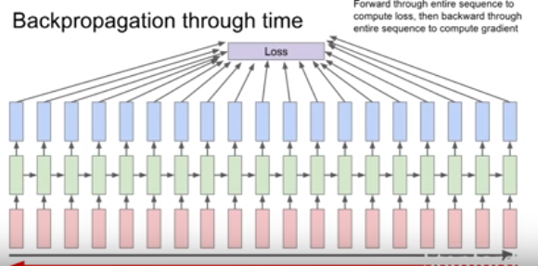

This could be problematic if the seq is very very long; for ex training a model for the entire text of wiki

Fwd pass thru the entire text of all wiki,then backwrd pass thru all, and finally making a single gradient update will be extremely slow, taking lots of memory and time and will not converge

In practice people use truncated backprob thru time

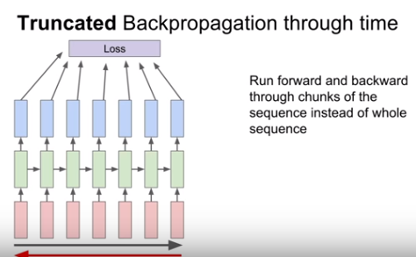

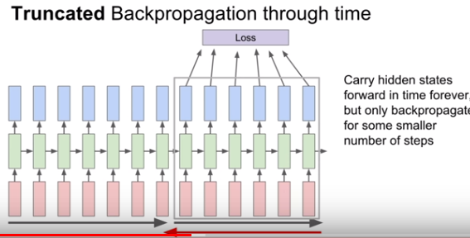

Question

Is this kind of making the Markov assumptions?

Not really, because we’re carrying this hidden state forward in time forever,

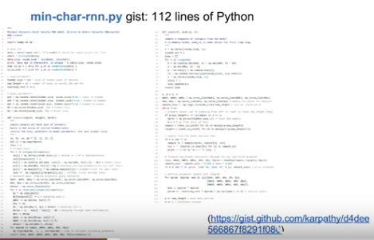

## Image Captioning

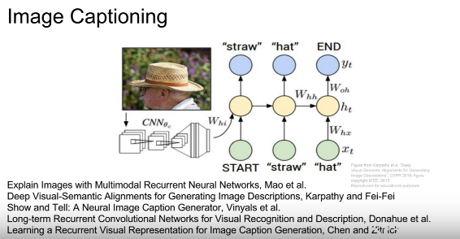

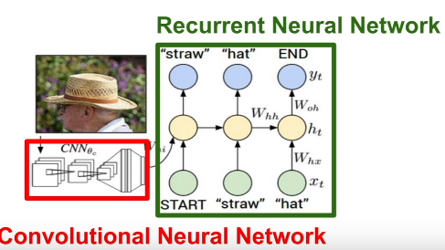

* CNN will produce a summary vector of the image ; which will then feed into the first time step of RNN language models which will then produce words of the caption one at a time
* At test time

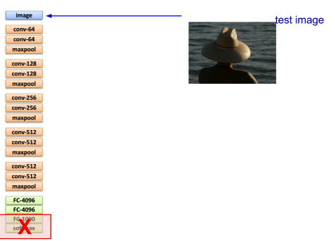 -> 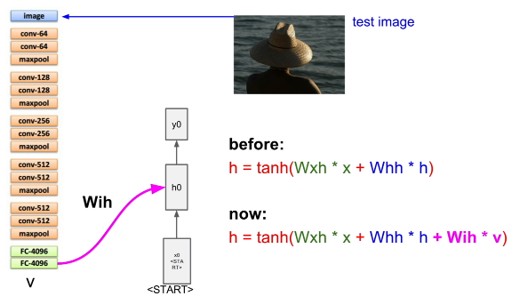

* Instead of softmax layer, we’ll use the FC4096 to summarize the whole content of the image.
* There is start token which enables the model to generate a word.
* 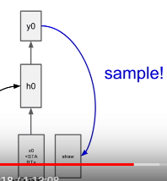 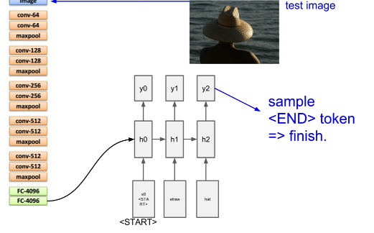
* When end token is seen the model stops sampling.
* Supervised learning dataset -> Microsoft coco

## Image captioning with Attention

* 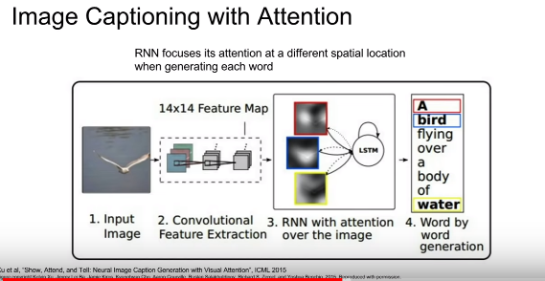
* An advanced model

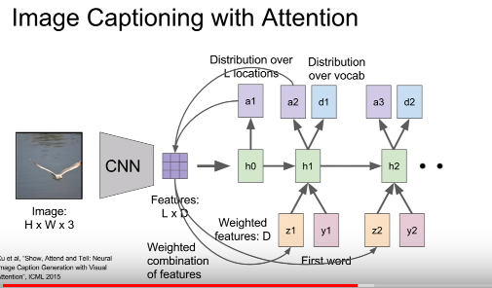

* CNN rather than producing a single vector summarizing the entire image, now it produces some grid of vectors that summarizes one vector for each spatial location
* In addition to sampling the vocabulary at every time step, it also produces a distribution over the locations in the image where it wants to look
* And now this distribution over image locations can be seen as a kind of a tension where the model should look during training; so that in the first hidden state computes this distr over image locs, which then goes back to the set of vectors to give a single summary vector that maybe focuses the attention on one part of the image
* The new hidden state will produce to outputs :
  + One is our distr. over vocabulary words
  + The other is a distr over image locs

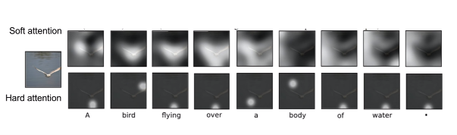

* After training it will shift its attention around the image for every word that it generates in the caption
* Here you can see, it produced the caption a bird is flying over,

## Multilayer RNNs

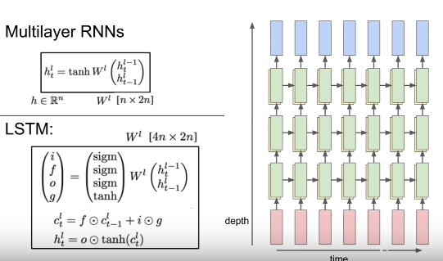

**You typically don’t see super deep models in RNNs. 2,3,4 is layer rnn is common,**

## Vanilla RNN Gradient Flow

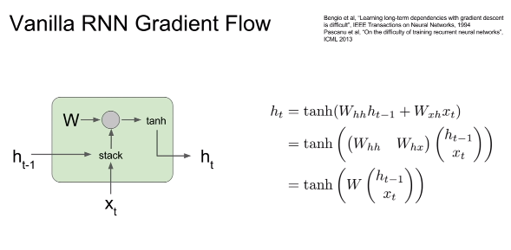

What happens in this architecture during the backward pass when we try to compute gradients?

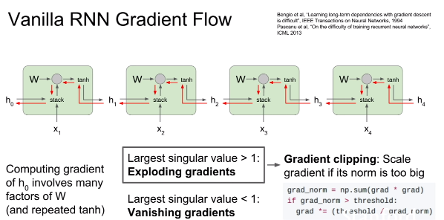



Changing rnn architecture means using lstm ,gru etc.

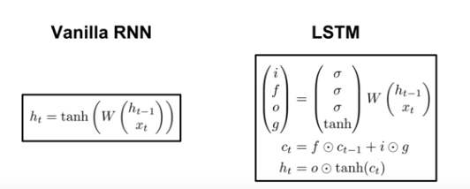

In vanilla there is only 1 hidden state, whereas lstm has 2 hidden state(ct-cell state and ht)

Ct is inside LSTM, doesnot exposed to outside world

## LSTM

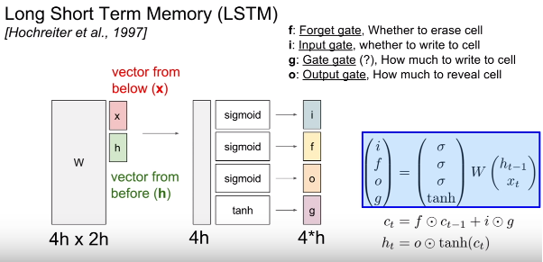

* In the vanilla rnn, we took two input vectors(x and h), concatenate them, then we did a matrix multiply to directly compute the next hidden state in the RNN
* LSTm does something a little bit different; we take the prev hidden state and x as input, stack them, Multiply by a very big weight matrix W, to compute 4 different gates which has the same size as the hidden state
* Only gate-gate uses tanh so the values in it will be between -1 & 1
* The other gates uses sigmoid that means 0 to 1
* After computing the gates, if you look at this next equation, you can see that our previous cell state is being multiplied elementwise by the forget gate
* You can think of this forget gate as being a vector of zeros and ones that telling us for each element in the cell state, do we want to forget that element of the cell in the case if the forget gate is zero?
* Or do we want to remember that element in the case of forget gate is 1

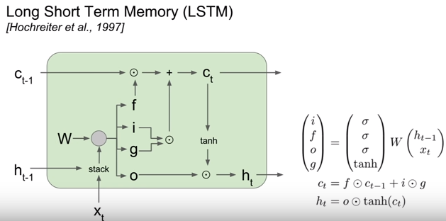

We saw in vanilla rnn during backward prop vanishing and exploiding gradient problems occur.

**What is happening to LSTM’s during backward pass?**

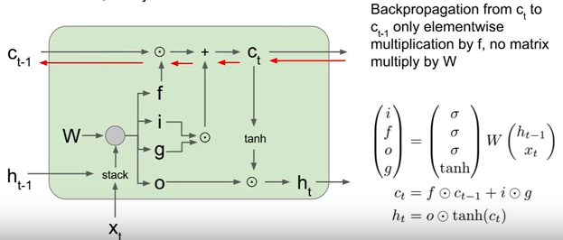

When we have our upstream gradient from the cell coming in, then once we backprop backwards through this addition operation, remember that this addition copies that upstream gradient into the two branches. So our upstream gradient gets copied directly and passed directly to backprop thru this elementwise multiply.

So then our upstream gradient ends up getting multiplied elementwise by the forget gate. As we backprop backwrds thru this cell state, the only thing that happens to our upstream cell state gradient is that it ends up getting multiplied element wise by the forget gate; so this is really a lot nicer than vanilla rnn for two reasons:

1. One is that this forget gate is now an **element wise multiplication rather than a full matrix** multiplication. So element wise multiplication is going to be a little bit nicer than full matrix multiplication
2. Second is it elementwise multiplication will potentially be multiplying by a different forget gate at every time step.

* So in vanilla rnn we were continually multiplying by that same weight matrix over and over again

which led to these exploding or vanishing gradients.

* But in LSTM; this forget gate can vary from each time step , now it is much easier for the model to avoid these problems (exploid or vanish)
* Finally, this forget gate is coming out from a **sigmoid** , this element wise multiply is **guaranteed to be between zero and one.**
* In vanilla during backprop our gradients were flowing thru tanh at every time step; but in lstm

Our hidden state is used to compute those outputs yt;

* If you imagine backprob from the final hidden state back to the first cell state. Then thru that backward path we only backprop thru a single tanh nonlinearity , rather thant thru separate tanh at every time step

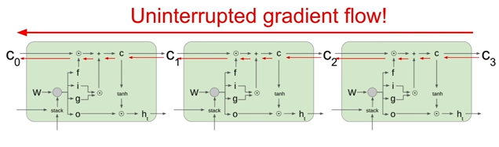

**Question: what about gradient in respect to w?**

At every time step, we will take our current cell state, that will give us our local gradient on w, so because our cell state we’ll end up adding those first time step w gradients to compute our final gradient on w

Imagine we have a very long sequence

We’ll get a local gradient on w for each time step and that local gradient on w will be coming thru these gradients on c and h. So because we’re maintaining the gradients on c much more nicely in lstm, those local gradients on w at each time step will also be carried fwd and bckwrd

much more cleanly.

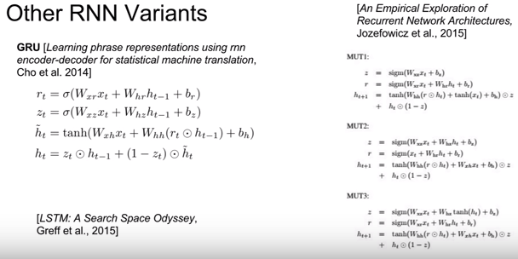

## Summary

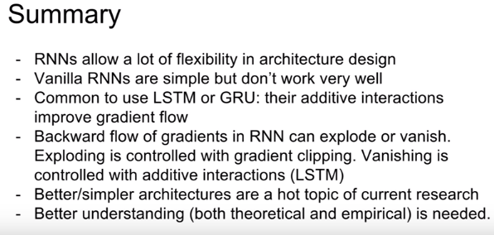

# L11 Detection&Segmentation

.Net2Net Ian goodfellow

## Semantic Segmentation

Anlamlı Parçalara Ayırma

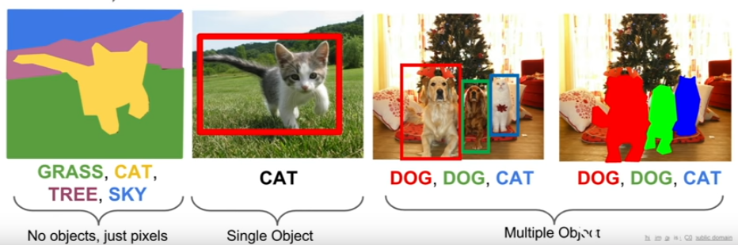

We want to know for every pixel in that image is it a cat, grass or sky. Rather than labelling to the entire image, we want to produce category label for each pixel of the input image.

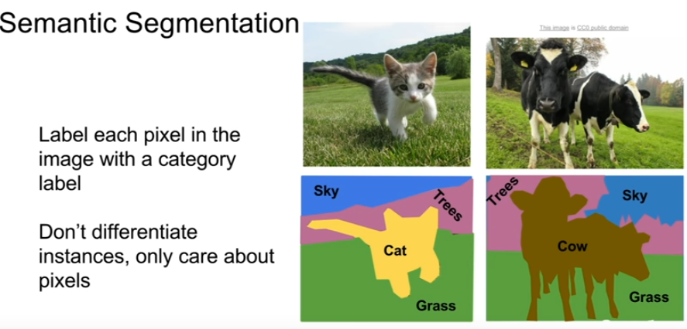

It doesnot differentiate instances. There are two cows, but semantic segmentation works independently for what is the category of that pixel. The output doesn’t distinguish two cows but labeling as cow only.

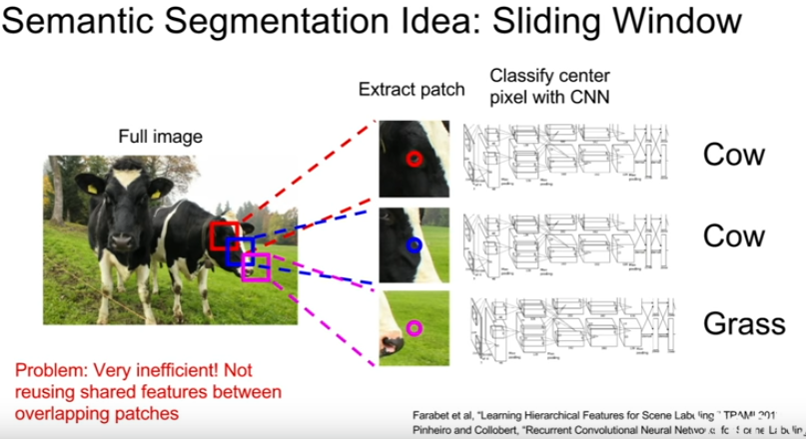

Classifiying patches independently is a terrible idea, (computationally expensive) because we want to label every pixel in the image we would need a separate crop for every pixel in the image. It will super expensive to run forward and backward passes thru. The patches next to each other(overlapping) share the same convolutional layers and a lot of computation is going to be repeated.

## Next idea : Fully convolutional

Rather than extracting individual patches from the image and clasifiying these patches independently, a giant stack of conv layers with no fully connected layers.

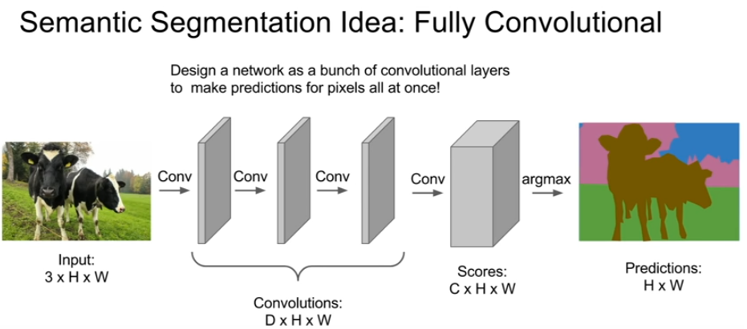

C is the number of categories we want to classify

We’ll compute the loss of every pixel, taking average over those pixels . Training will be expensive. We have to label every pixel.

**Question**: what is the loss function?

* Since we’re making a classification decision per pixel, we put a **cross entropy loss** on every pixel of the output. We have the ground truth category label for every pixel in the output , then we compute across entropy loss between every pixel in the output and the ground truth pixels and then taking either a sum or an average over space and then sum or average overy the mini batch.

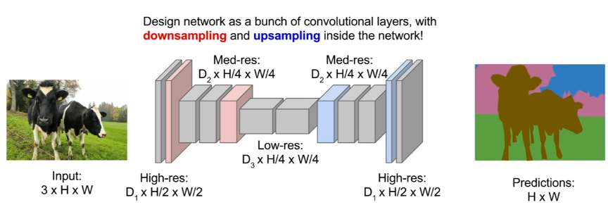

## Unpooling

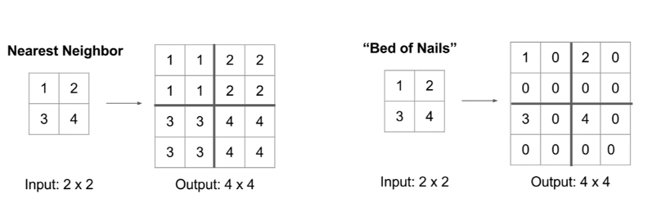

## Max unpooling

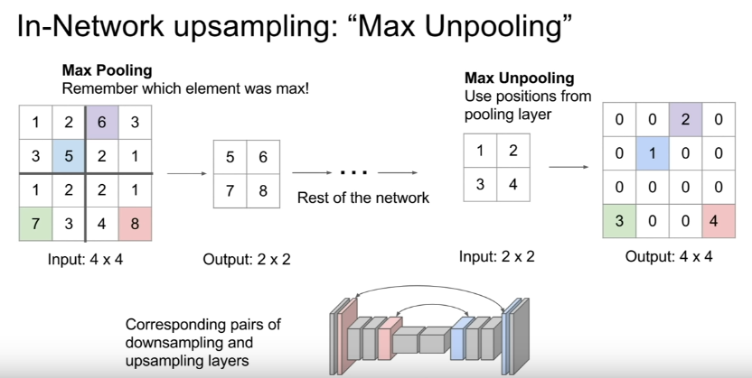

It is associated with one of the pooling layers in the first half of the network(downsampling)

**Question: Why is it a good idea?**

When we’re doing semantic segmentation , we want our predictions to be pixel perfect, we want to get those sharp boundaries . So now if you are doing this max pooling , there is a heterogeneity that’s happening inside the feature map due to the max pooling where from low resolution image you don’t know , you’re sort of loosing spatial information in some sense by you don’t where that feature vector came from in the local receptive field after max pooling .

So if you actually unpool by putting the vector in the same slot, you might think that might help us handle these fine details a little bit better ; and help us preserve some of that spatial information that was lost during max pooling

## Transpose Convolution

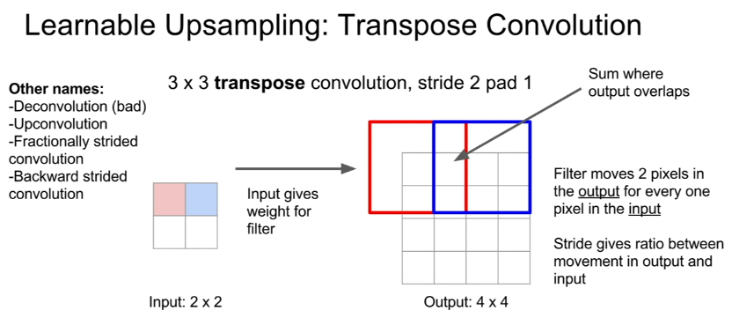

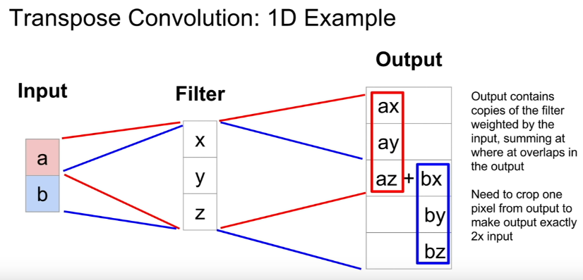

Where does this transpose convolution come from?

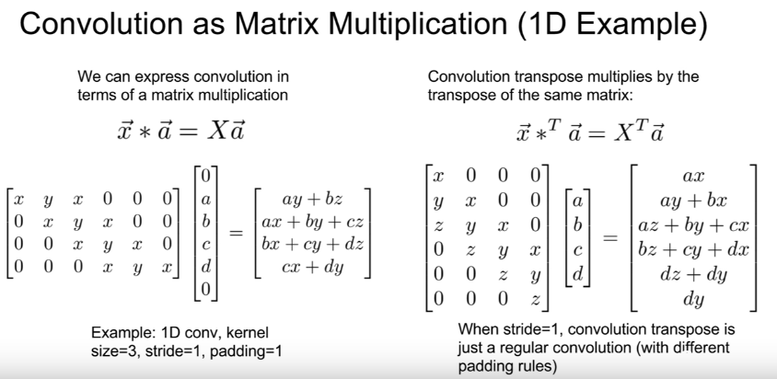üstteki resimde 3.col z olacak!

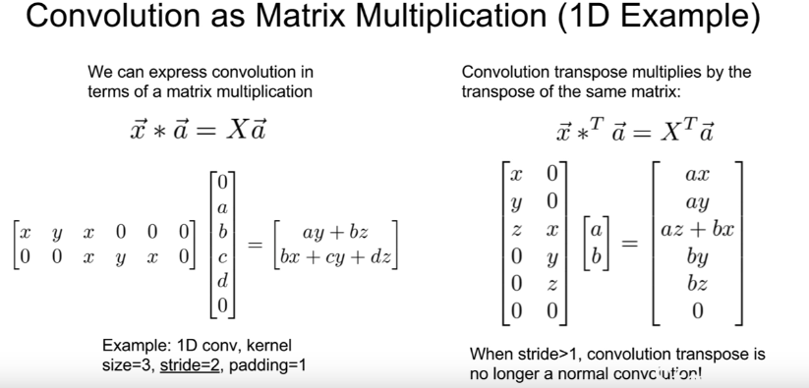

Question: Why we sum not average ?

* The reason we sum is due to this transpose convolution formula,

## Classification+ Localization

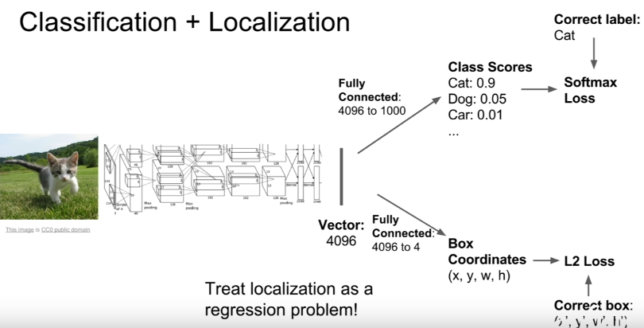

There are two loss functions ; one for **classification** of cat; other for **localization**(regression) .

* For **Classification** : Cross entropy loss or softmax loss or SVM margin type losses .
* **Regression** loss: L2 Euclidean or L1 loss.
* Classification vs Regression-> categorical vs continous

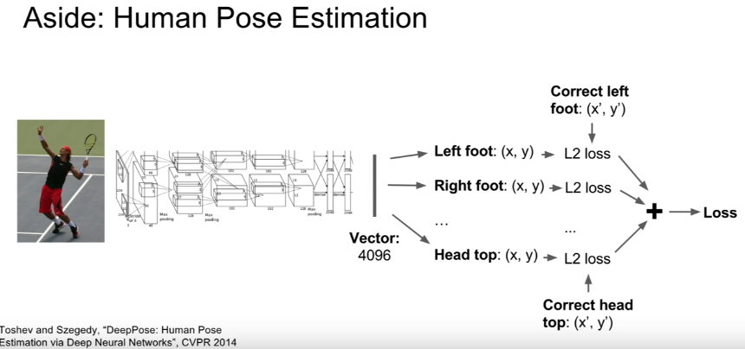

## Object Detection

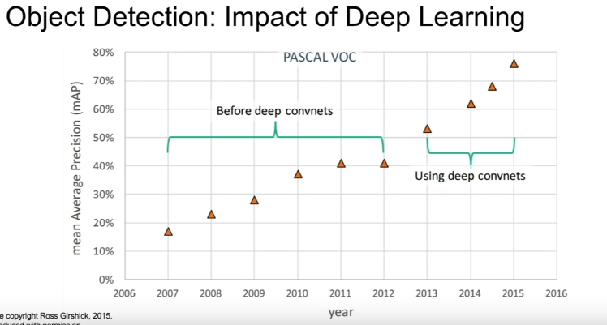

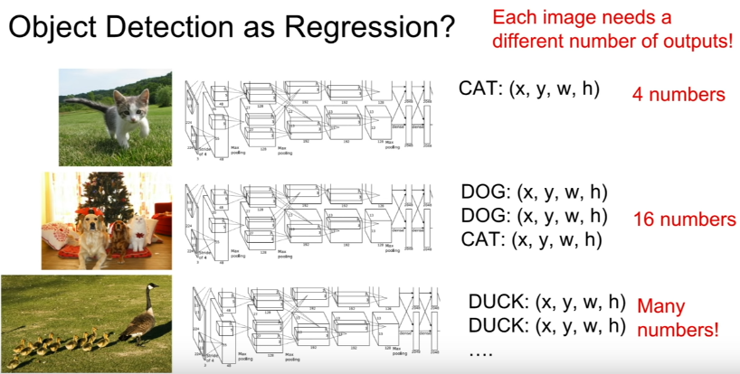

## Sliding window for Object detection

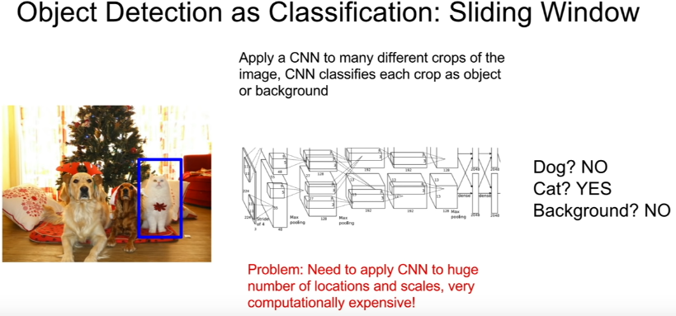

* We cut out patches from the picture according to the sliding windows, The patches are warped since many classifiers take fixed size images only.

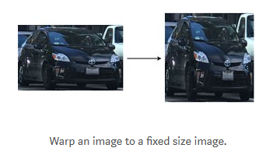

* The warped image patch is feed into a CNN classifier to extract 4096 features. Then we apply a SVM classifier to identify the class and another linear regressor for the boundary box.

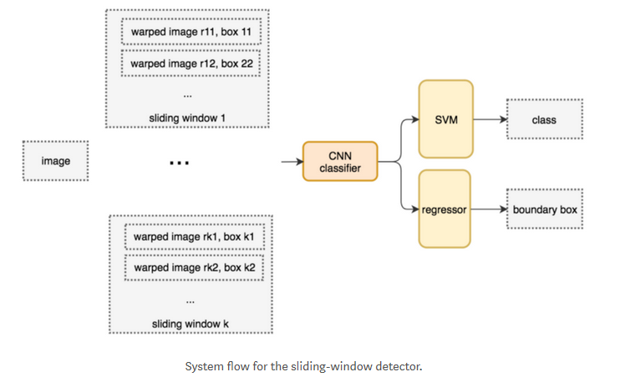

**Question** : How do we choose the crops of the image?

Because these objects could appear at any location, at any size, at any aspect ratio ; so if you want to do kind of a brute force sliding window approach you’d have to test tens of thousands many different crops (which will be fed to CNNs computationally intractable ) in order to tackle this problem. So in practice this is not used.

## Region Proposals

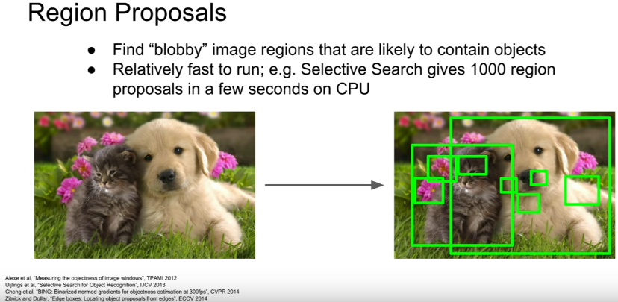

## Selective search

* Instead of applying our classification network on the entire image, first apply region proposal networks to get some set of proposal regions where objects are likely located and apply a conv net for classification to each of this proposal regions and this will end up being much more computationally tractable.(işlenebilir)
* Instead of a brute force approach, we use a region proposal method to create regions of interest (ROIs) for object detection.
* In selective search (SS), we start with each individual pixel as its own group. Next, we calculate the texture for each group and combine two that are the closest.
* But to avoid a single region in gobbling others, we prefer grouping smaller group first. We continue merging regions until everything is combined together. In the first row below, we show how we grow the regions, and the blue rectangles in the second rows show all possible ROIs we made during the merging.

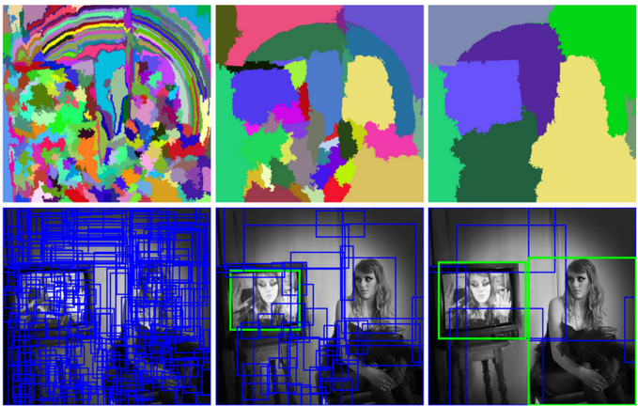

## R-CNN

* R stands for region

One specific problem of ROI is the regions can be in different size. But cnn wants images of the same input size typically. So we have to take each of this regions and **warp them to that fixed square size**.

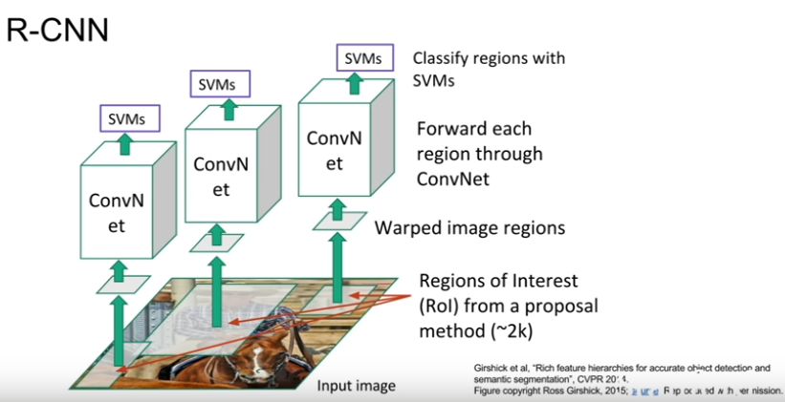

R-CNN also predicts a regression (like a correction to the bounding box) in addition for each of these input region proposals , because the problem is that your input region proposals are kind of generally in the right position for an object but they might not be perfect.

So R-CNN will _in addition to category labels for each proposals_ also **predict four numbers that are kind of an offset or an correction to the box that was predicted at the region proposal stage**

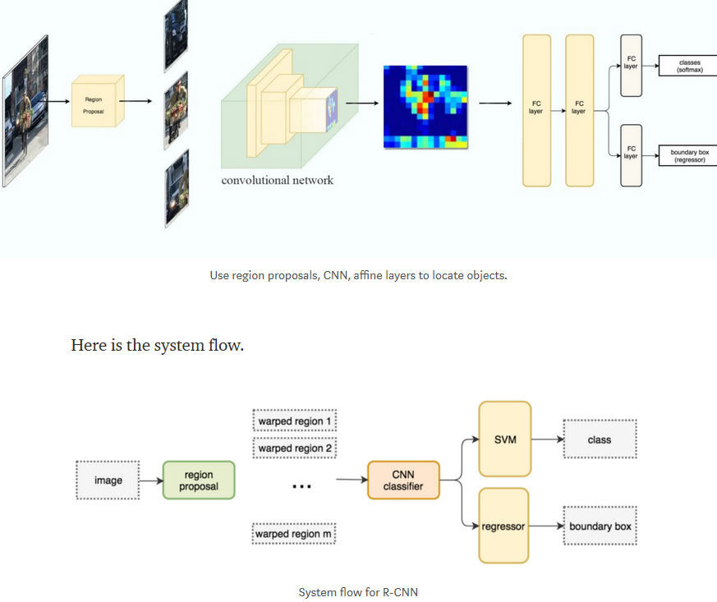

**Question: Is it necessary for regions of interes(ROI) to be rectangles?**

To warp these nonregion things it is the easiest, but once you move to something like instant segmentation then you sometimes get proposals that are not rectangles.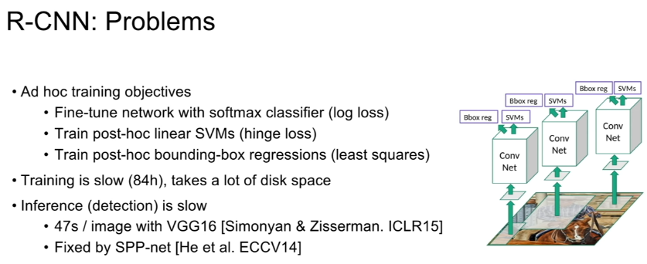

* It is still computationally expensive, because if 2000 regions detected, it will run for each of the region independently
* It is slow, it would actually dump all the features to disk ; so it’d take hundreds of GB of disk space to store all these features. Than training will be super slow. 84 hours to train, 30 seconds minute per image at test time ,

## Fast R-CNN

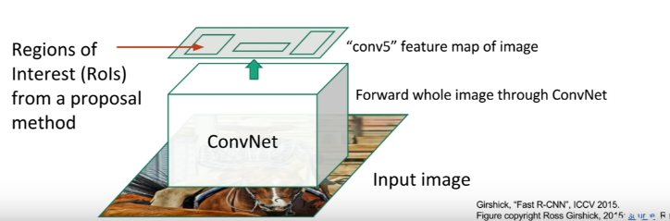

* **Rather than processing regions seperately ; we’re going to run the entire image thru some conv layer all at once.**
* We still are using some region proposals from some fixed thing like selective search, but rather thant cropping out the pixels of the image corresponding to the region proposals instead we imagine projecting those region proposals onto this conv feature map
* Then taking crops from conv feature map from proposal rather thant takip crops directly from the image. This allows us to reuse conv computation across the entire image when we have many many crops per image
* But again if we have some FC layers downstream, those FC layers are expecting some fixed_size input so now we need to do some reshaping of those crops from the conv.feature map.(by using ROI pooling layer)

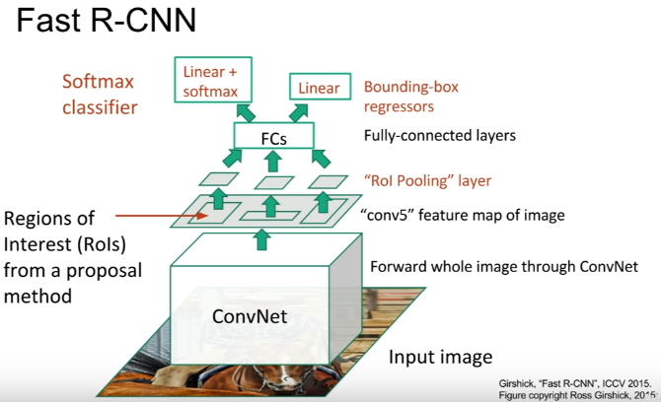 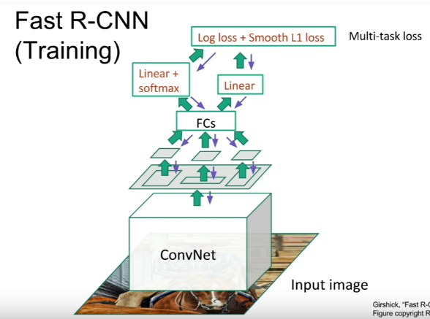

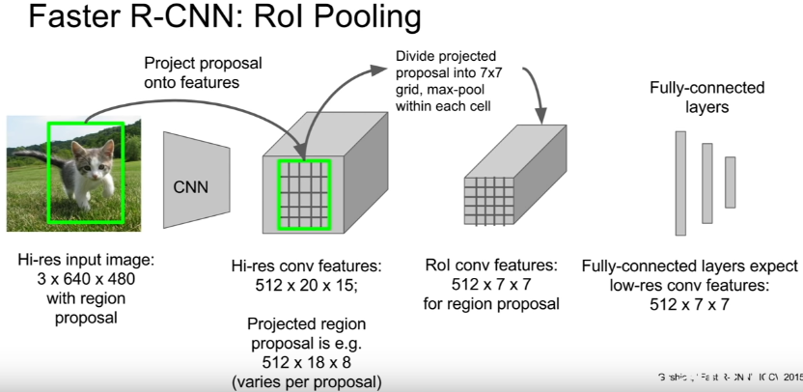

*From: medium.com*

* *R-CNN needs many proposals to be accurate and many regions overlap with each other. R-CNN is slow in training & inference. If we have 2,000 proposals, each of them is processed by a CNN separately, i.e. we repeat feature extractions 2,000 times for different ROIs.*
* *Instead of extracting features for each image patch from scratch, we use a* ***feature extractor*** *(a CNN) to extract features for the whole image first.*
* *We also use an external region proposal method, like the selective search, to create ROIs which later combine with the corresponding feature maps to form patches for object detection*
* *We warp the patches to a fixed size using* ***ROI pooling*** *and feed them to fully connected layers for classification and* ***localization*** *(detecting the location of the object****). By not repeating the feature extractions, Fast R-CNN cuts down the process time significantly.***

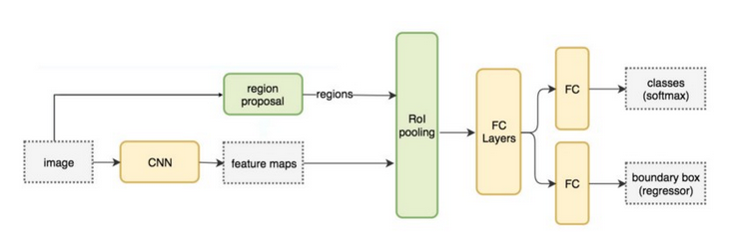

*One major takeaway for Fast R-CNN is that the whole network (the feature extractor, the classifier, and the boundary box regressor) can be trained end-to-end with* ***multi-task losses*** *(classification loss and localization loss). This improves accuracy.*

## ROI

*Because Fast R-CNN uses fully connected layers, we apply* ***ROI pooling*** *to warp the variable size ROIs into in a predefined size shape.*

* *Top left below: our feature maps.*
* *Top right: we overlap the ROI (blue) with the feature maps.*
* *Bottom left: we split ROIs into the target dimension. For example, with our 2×2 target, we split the ROIs into 4 sections with similar or equal sizes.*
* *Bottom right: find the maximum for each section and the result is our warped feature maps.*

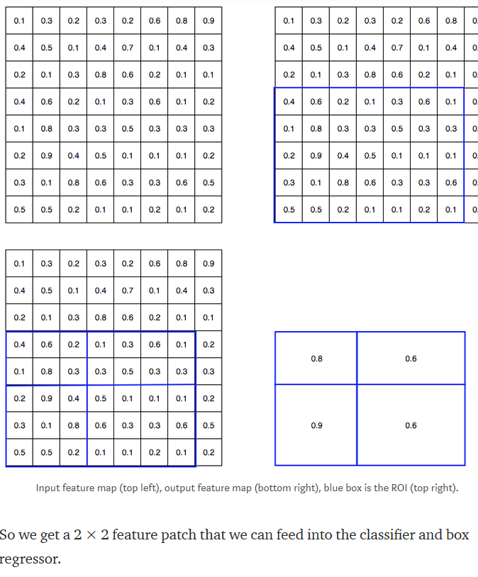

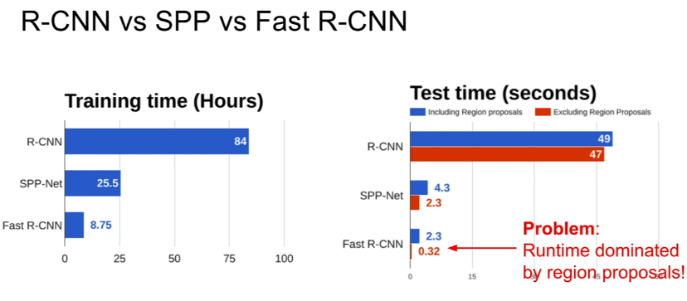

## Faster R-CNN

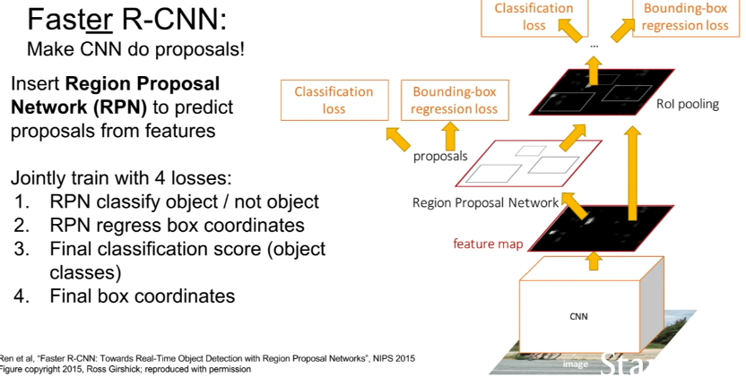

*Fast R-CNN depends on an external region proposal method like selective search. However, those algorithms run on CPU and they are slow. In testing, Fast R-CNN takes 2.3 seconds to make a prediction in which 2 seconds are for generating 2000 ROIs.*

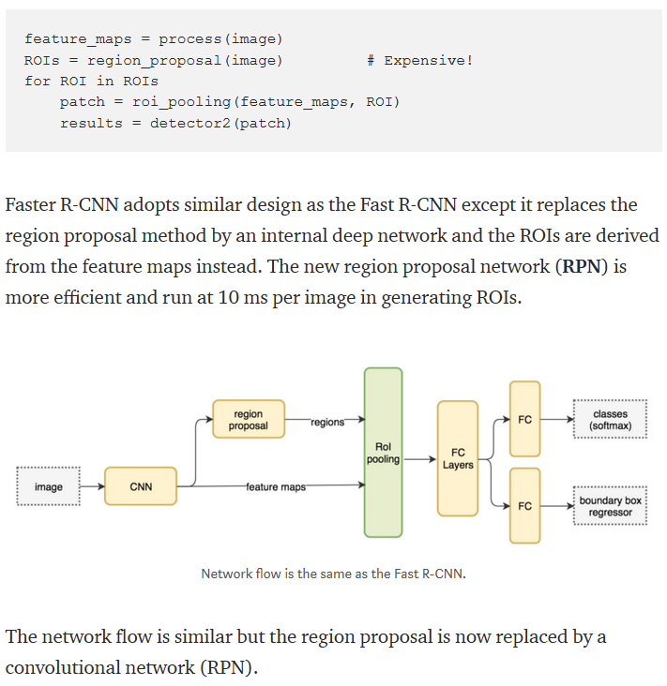

**Question : How do you train this region proposal network,b**ecause you don’t have ground truth region proposals for the region proposal network

* + The idea is that at any time you have region proposal which has more than some threshold of overlap with any of the ground truth objects, then you say that that is the positive region proposal . You should predict that as the region proposal ,
  + And any potential proposal which has very low overlap with any ground truth objects should be predicted as a negative ;
  + there are also lots of dark hyperparams in that process and that’s a little bit hairy.

**Question: What is the classification loss on the region proposal network?**

* It’s making binary decisions , so it has some set of potential regions that it’s considering and it’s making binary decision for each one (is this an object or not an object) It’s like a binary classification loss

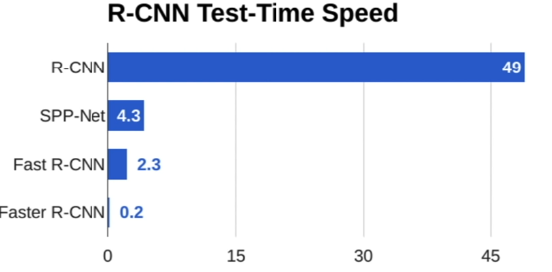 These are all called as region-based methods for object detection

## Detection without proposals

Yolo/SSD

SSD: Single Shot Detection

There is another method grup which is sort of all feed forward in a single pass

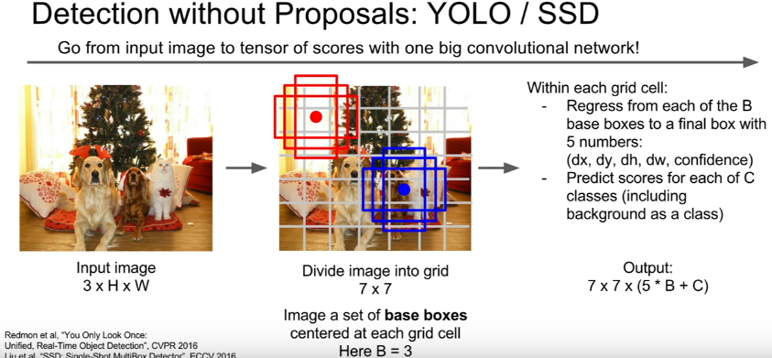

* **Rather than processing for each of these potential regions** ,we want to treat this like a **regression problem and just make al these predictions all at once** with some big conv network
* B for location, C for categories classes
* So now given our input image , you imagine dividing that input image into some coarse grid (7x7 grid in this example) .
* Now within each of those grid cells, you image some set of base bounding boxes(3 here tall one, wide one and a square one) _in practice it is more than 3
* For each of these grid cells and for each of these base bounding boxes you want to predict several things .
  1. You want to predict an offset of the base bounding box for the true location
  2. You also want to predict the classification scores for the base bounding boxes,how likely is that an object of this category appears in this box.
  3. At the end we end up predicting this giant tensor of 7x7 gid by 5*B+C
* Region proposal network that gets used in faster R-CNN ends up looking quite similar to these where they have some set of base bounding boxes over some gridded image , another region proposal network does some regression plus some classification
* So there’s kind of some overlapping ideas here , in faster R-CNN we’re kind of treating the object _the region proposal step _ as kind of this fixed end_to_end regression problem and then we do the separate per region processing.
* But now with these single shot methods, we only do that first step and just do all over object detection **with a single forward pass.**

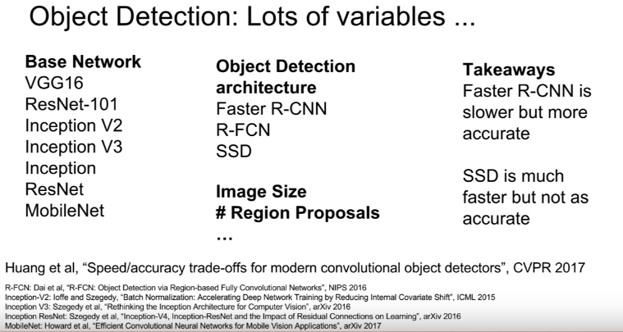

SSD don’t require per region processing, it is faster than faster R-CNN

## Dense Captioning

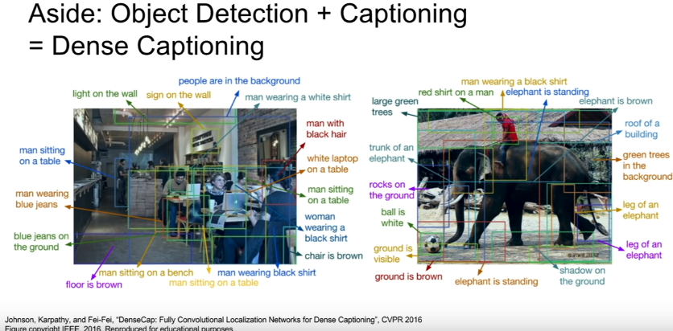

* Rather than predicting a fixed category label for each region , instead we want to write a caption for each region.
* Rather than a SVM or a softmax loss, it has a RNN language model that predicts a caption for each region.

## Instance Segmentation

Instead of creating a boundary box, image segmentation groups pixels that belong to the same object

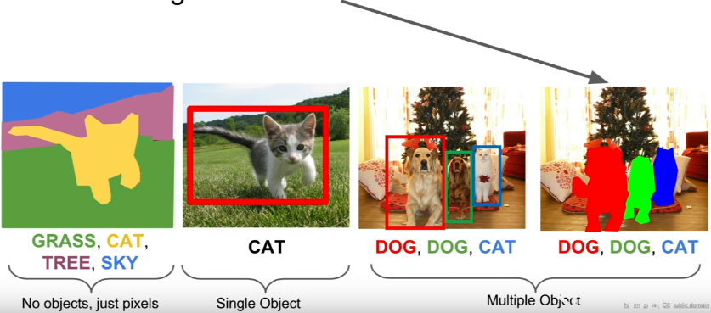

## Mask R-CNN

It is like faster R-CNN

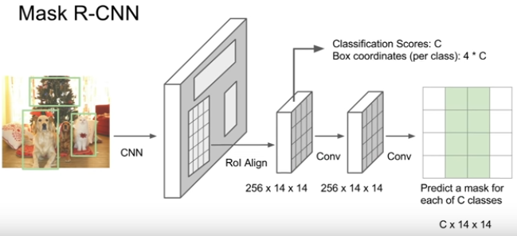

* Image goes into **CNN and some learned region proposal network** that’s exactly the same as faster R-CNN
* Once we have our learned region proposals, we project these proposals onto our convolutional feature map just like we did it in faster R-CNN
* But now **rather than just making a classification** and a bounding box for regression decision for each of those boxes we in addition want to **predict a segmentation mask for each of those region proposals.**
* So it kind of looks like a semantic segmentation problem inside each of the region proposals that we’re getting from our region proposal network.
* So now after we do this ROI aligning to warp(eğme) our features corresponding to the region of proposal into the right shape
* Then we have two different branches ; first one to predict classification scores(whether it is background or not) we’ll also predict some bounding box coordinates

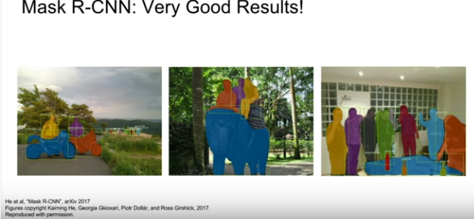

Training data set from Microsoft Coco.(200K images) 80 categories.

## Summary

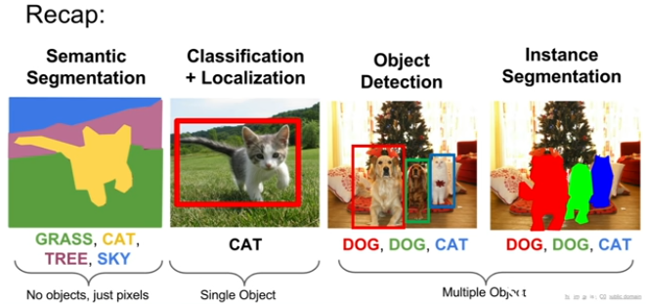

## Extra read

<https://medium.com/@jonathan_hui/what-do-we-learn-from-region-based-object-detectors-faster-r-cnn-r-fcn-fpn-7e354377a7c9>